The following is the pre-code planning for a simple program that averages 5 grades, and displays the result as well as whether or not the student passed.
The flowchart is as follows:
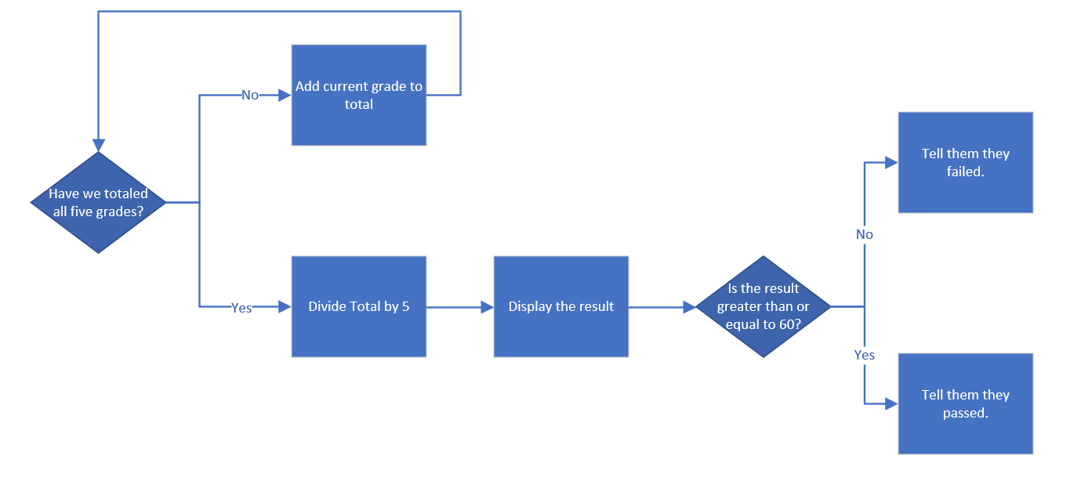
The pseudo-code is as follows:
gradeAverage{
int GradeTotal = 0;
int CurrentGrade;
float gradeAverage = 0;
int Grade1 = 23;
int Grade2 = 87;
int Grade3 = 93;
int Grade4 = 29;
int Grade5 = 90;

for (CurrentGrade is equal to or less than five) {
add the current grade to the grade total and loop back.
increment CurrentGrade to keep track of loop position.
}

display the average grade.

if the average grade is above or equals to 60,
then tell them they passed.
else,
then tell them they failed.
}

